Sensors for Exercises

1. 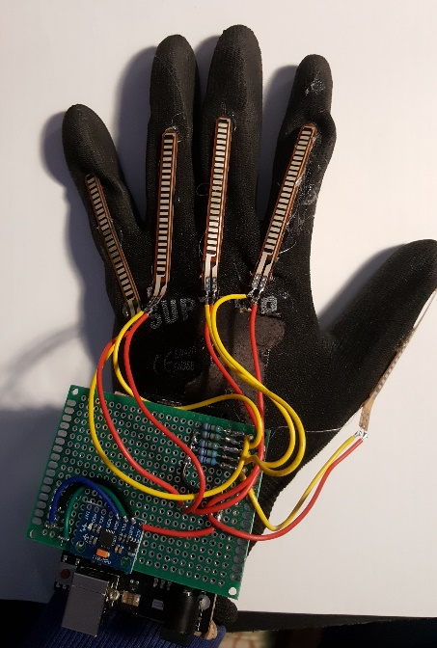**Flex sensor**

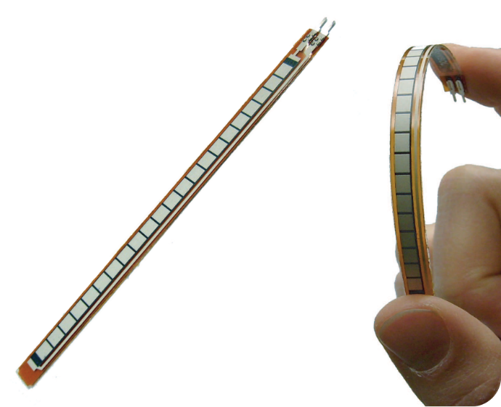

* Flex sensor is a sensor that measures resistance. It can be used in this project to detect posture when exercising.
* ρ = RA/l
* where ρ = resistivity of a material
* R = Resistance
* A = Area of the material
* l = Length of the material

(Arduino, 2021)

(Ng, 2019)

(Sparkfun, n.d.)

1. **Gyroscope MPU6050 3 axis**

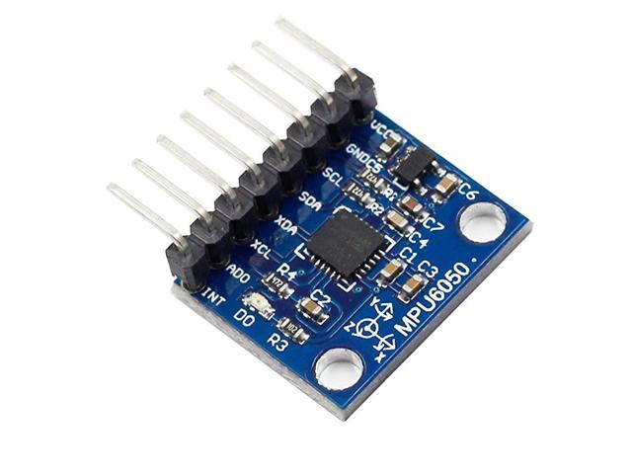

* Gyroscope measures rotational velocity or rate of the and angular position along X, Y, Z axis meaning acceleration.
* can be used to identify movement patterns
* Measurement unit : Degrees per second. deg/s

(Arduino, n.d.) (neweggbusiness, n.d.)

1. **Ultrasonic sensor**

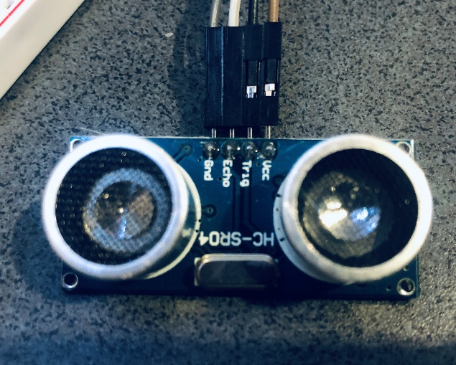

* Measures distance using ultrasound at 40kHz. The waves bounces off an object and measures the distance based on the time it takes to bounce back. Can be used to calculate the fatigue, rate and posture of pushups and other dynamic exercises.
* Speed of sound unit : m/s program to get distance in m, cm.

(Arduino, n.d.)

1. **PIR motion sensor (Passive Infrared Sensor)**

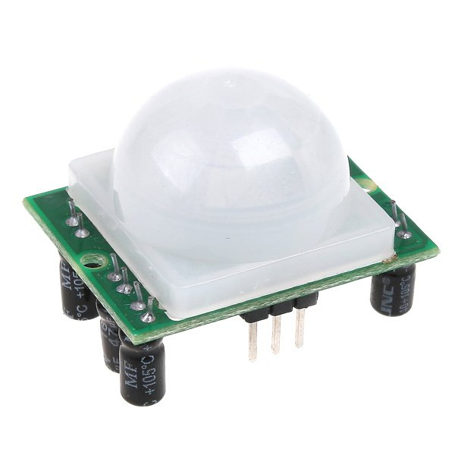

* Detects movement of objects that radiate IR light.
* No measurement unit.
* Output : 0, 1

(Arduino, n.d.) (Today, 2016)

1. **Infrared Sensor**

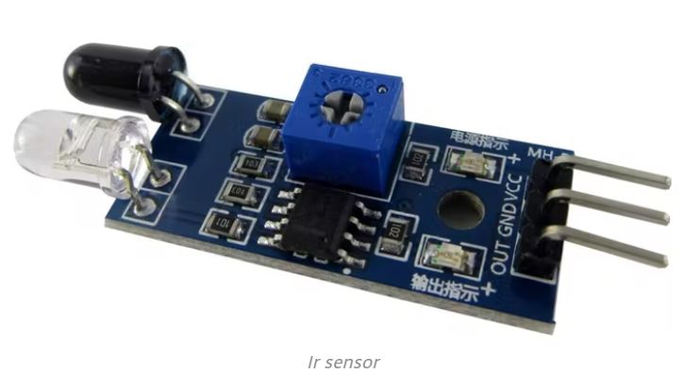

* Measures infrared radiation (not emitting it).
* Can be used to detect body heat with different exersices.
* No measurement unit.
* Output : 0, 1

(Arduino, n.d.)

1. **XD-58C heartbeat sensor**

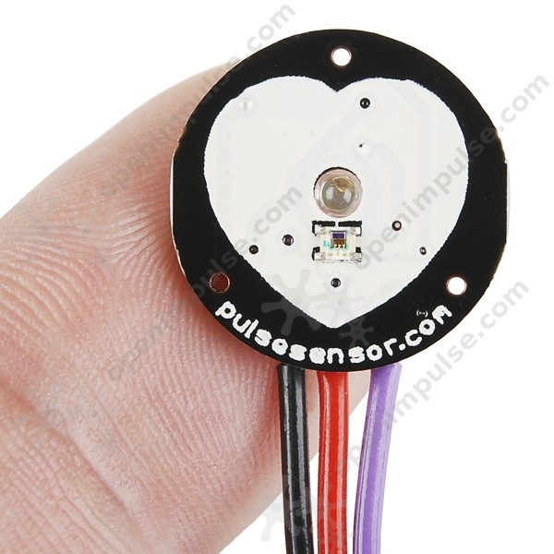

* Measures Heartbeat/pulse rate BPM
* Can be used to measure heartrate or pulse when exercising